Chapter 4, Problem 94.

An attenuator is an interface circuit that reduces the voltage level without changing the output resistance.
- By specifying R_{s} and R_{p} of the interface circuit in Fig. 4.150, design an attenuator that will meet the following requirements:
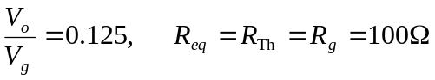
- Using the interface designed in part (a), calculate the current through a load of R_{L} = 50 Ω when V_{g} = 12 V.

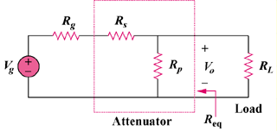

Figure 4.150
For Prob. 4.94.

